Greg Grube
8/21/22

Geography 778: Executive Summary

Project Background:

Working at the Wisconsin Elections Commission, our job is to help manage election systems in the state of Wisconsin to benefit both members of the public looking to register and vote, but also to help the 1,850 election clerks around the state run elections and manage elections data.

Our voter registration system utilizes mapping tools to visualize two essential parts of the election process that ensures voters are provided with the correct ballots: address points, which voter records are tied to when a voter registers, and voting districts, which help to determine the unique ballot style a voter would receive for a given election if their address falls within that voting district. Address data is updated as new homes or apartment buildings are constructed or if street names or addresses change over time.

District data can also change with annexations or school district changes, but these districts are largely static, other than every 10 years after the United States Census occurs. When population numbers are adjusted through the census, states then subsequently go through a process called redistricting that adjusts the boundaries of many districts at the federal, state and local levels. These include congressional, state legislative lines and even local town or city council districts. As a result, these changes may affect many voters who will see changes to the election races that appear on their ballot when they vote. Once the voting districts are determined by the local and state officials, the Wisconsin Elections Commission updates the voting systems to reflect these changes.

Project Purpose and Intended Audience:

The 2020 Redistricting cycle was particularly chaotic due to a combination of factors, beginning with census data arriving late, and then continuing with compressed timelines and lawsuits that occured in state and federal courts. As a result, local municipal and county officials had to work quickly to implement their local boundaries and then wait until the state legislature finished the boundaries for congressional and legislative lines. Normally, these processes would be completed over the course of six months, but everyone was working on compressed timelines which made the process confusing for local election officials. This confusion was made worse by multiple lawsuits that caused state legislative lines to change and be uncertain for months.

Now that the redistricting processes are largely complete, our office still receives questions about district assignments, especially as we get closer to the fall election cycle. The purpose of this project is to help answer these district questions by designing a map that could be used by municipal and county clerks to visualize districts in a much more effective way than the current voter registration system allows. This includes the new districts created during redistricting, but also includes other districts like schools that do not change during redistricting. My hope is to make an intuitive map that could be consumed by clerks and election staff to determine where boundaries are for their level of government. Though clerks are the target audience, I also hope that the maps could be beneficial to members of the public as well.

Application Overview:

The application is designed to contain all of the statewide election district datasets, ranging from Congressional districts down to local districts such as schools or sanitary districts.
Though the map is data rich, it is also designed to be easy to use and flexible and to fit different use cases. So, each layer has the ability to have labels turned on and off and the ability to change transperancy. There is also the ability to use different basemaps and to search for specific counties, municipalities or school districts. A user could also zoom directly to their current location if they desire.

The user can also filter some of the more visually complicated local datasets, such as wards or county supervisor districts, by municipality or county to allow a cleaner look at those. They just need to click on the municipality or county and then select a spatial relationship to view that data more easily. Finally, the application also allows for pop-up information on the majority of the datasets and has a print function that can be used to print out a paper reference map if needed.

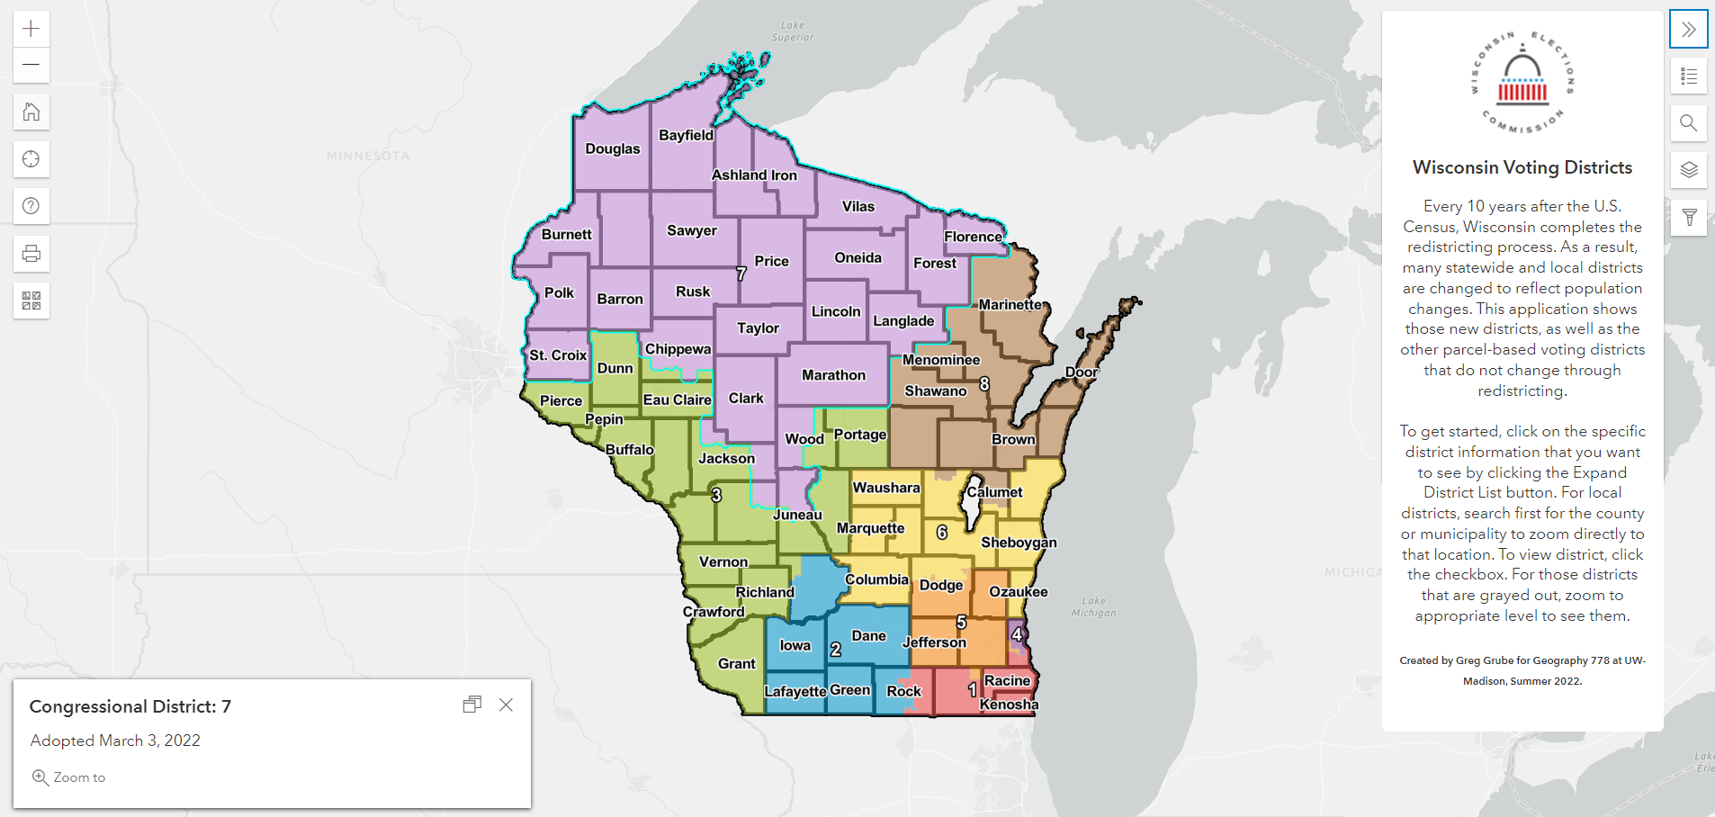
Figure 1: Map with introductory message window open and congressional dataset selected

Example Uses:

The webmap is designed first and foremost for election staff, but also can be useful for candidates or members of the public as well. One example of a use would be a county clerk using the map to determine which municipalities are within certain districts for statewide elections. County Clerks are in charge of working with voting machine vendors on behalf for their municipal clerks, so having a map to look at is extremely valuable to avoid problems with ballot printing and voting equipment mismatches with the state's election systems.

Municipal clerks could also use this map in order to discover which districts are found within their municipality. The print function could be useful for sending the maps to the polling place workers for that they know which areas of the city, town or village are in certain voting districts. They could also use it to verify voter questions on where the ward boundaries are or any changes that have occured due to redistricting.

Finally, the map could be useful for candidates who are running for office. If a candidate has a map of the boundaries of the district that they are planning to run in, they could use that to devise a strategy to collect signatures or to reach out to their constituents with information. They could use the print tool to print out maps for volunteers that are helping with their campaigns as well to make sure that they are contacting the correct voters in the correct districts.

Development: Data

This application contains 16 different datasets representing nearly all of the election districts that could exist on a ballot in Wisconsin (there are two special school district types that only apply in Milwaukee and Racine counties, but those were omitted because they were not statewide). The districts are split between being parcel-based (like school or sanitary districts) or census-based (state assembly or county supervisory). Some of the datasets are tied very closely to county and municipal lines, so I included those geographies as well to give additional context to the election data and to allow clerks to have easier search terms.

In addition to the data layers, this application also includes four basemaps. Three of the basemaps are from ESRI's library, while the other dataset was derived from a Mapbox version. One of the ESRI basemaps was used out of the box as it was simply an aerial with no labels. The other two datasets needed to be altered slightly because they included municipal and county labels, which were already included on my county and municipality data layers. So I was able to remove those from the basemap as to not have duplicate labels appear when both are turned on. The Mapbox dataset was used because ESRI does not have a vector version of their Aerial with Labels basemap, so I used the Mapbox version which did allow for this functionality to remove the municipal and county labels.
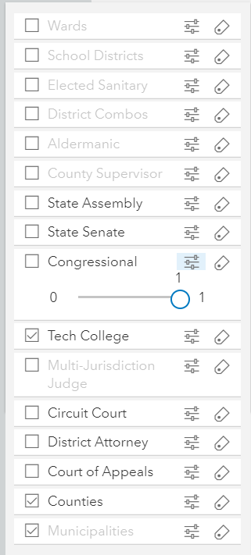
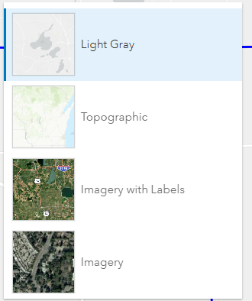
Figure 2: Basemap Selection List and Election Data Layer List

Development: Functions/Design

One of the biggest advantages of using ESRI's Javascript API is that it has many widgets that are easy to use without too much customization. There is also good documentation for how to customize if needed. Some of the functions like the legend widget, print widget and location finder were not changed much from their default settings, but other widgets like the basemap switcher, layer switcher and search were customized significantly to get them to work the way I was envisioning. And the filter function was also entirely built from pieces of other widgets to create a cohesive tool that I was looking for.

For the basemap switcher, I needed to remove the default basemap options and plug in my custom versions, which was a challenge. For the layer switcher, I replaced the eye symbol to the more classic checkbox option, as well as add opacity sliders and label toggle to each layer. For the search tool, I limited the search to only the schools, municipalities and counties and also added custom functionality to turn on a layer automatically if it was off when searched for.

By far the hardest functionality to implement was the filter tool. I wanted to allow the user to select items to filter spatially instead of from a list, given the nearly 2,000 counties and municipalities in the state. So, that relied on using geometry selection functionality applied to the two layers being compared to each other. And with the user having the option of jurisdiction type and spatial relationship to be displayed, I needed to make the tool be robust, yet flexible to handle the different inputs.

For overall design, the biggest challenge was to get all of the different data layers to display well on their own, as well as anticipate which layers would be used together. So, the municipality and counties are on by default, so I tried to design the other layers to display well with those and trying to get them to work with both aerial and non-basemaps. This was a significant trial and error process and determining which layers would be filled and which would be only outlined was difficult. I spent significant time getting qualitative color ramps that worked and with some layers like county supervisor that had upwards of 40 district numbers, that was a major challenge.

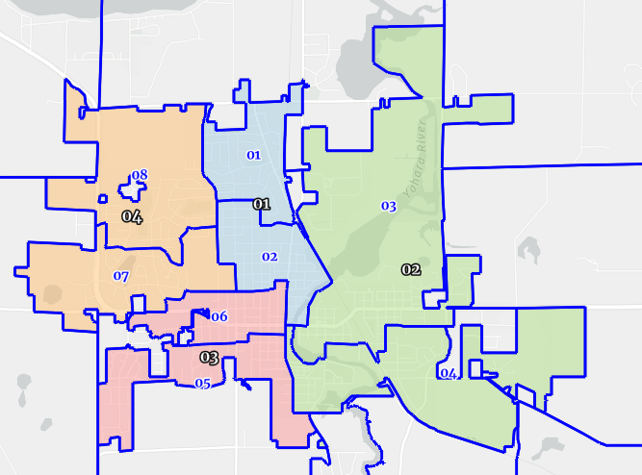
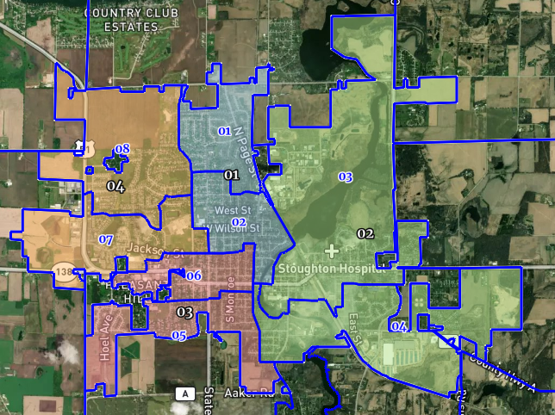
Figure 3: City of Stoughton showing wards and aldermanic districts with default basemap and with aerial photo

Conclusions:

Overall, I think the map serves its intended purposes. All of the major election datasets are included and were customized to fit their data types and their visual needs. I also was mostly happy with each of the widgets and their functionality, with the only issues left unresolved being items that were bugs within the Javascript API. For example, the print function would not display labels if you tried to export a map that was filtered at the time. I couldn't find documentation of that issue, unfortunately. I would have also liked to have opacity sliders on the basemaps as well as the data layers, but that would have been very complicated custom code, so I decided to leave that off for this version.

Other future features to add would be address point data so that users could search for their individual address and adding the elected official names to the datasets. Because the focus was mostly on clerk users for this version of the application, these datasets were not as essential, but would be useful for members of the public. Ultimately, I tried to limit the scope of the project to not include those elements so that I could focus on my goal of usability and clarity.

I think this project is a good summation of what I learned in my time in the graduate program. It combines cartographic and user experience considerations with development and database design. I was especially proud of the level of customization I was able to add to the webmap and the confidence in my programming skills improved exponentially from when I started.

